
SHE’S IN THE ATTIC

shesintheattic.com
Full Site Audit
Six Layer Report — June 2026

Crawl date: 24 June 2026
URLs crawled: 33
Prepared by: She’s in the Attic Ltd
Company No: 16258691
ICO No: CSN4052311
Classification: Internal use

1. Crawl Summary
The Archaeology layer — the technical foundation. This is the first thing we check. A site that cannot be crawled cannot be indexed. A site that cannot be indexed cannot be found. This section covers response codes, indexability, title and meta health, link totals, robots.txt configuration and image alt coverage. All data is measured from a direct crawl of the live site on 24 June 2026.

Response codes & indexability

Metric | Value | Status
Total URLs crawled | 33 | OK
200 OK | 28 | OK
3xx Redirects | 0 | OK
4xx Errors | 2 | FAIL
5xx Errors | 0 | OK
Indexable pages | 26 | OK
Non-indexable pages | 4 — see list below | WARN

Non-indexable pages (review each to confirm intent):
- thank-you.html — noindex, nofollow. Correct — post-form confirmation page.
- cookie-policy.html — noindex. Correct — legal page, no search value.
- privacy-policy.html — noindex. Correct — legal page, no search value.
- /migrations.html — 404, no index signal. Needs building or links removing.

robots.txt

Signal | Status | Notes
robots.txt present | Yes | OK
Sitemap declared in robots.txt | Not checked | WARN
AI bot rules (GPTBot, ClaudeBot etc) | Not specified | WARN
Crawl-delay set | Not set | OK

On-page signals

Metric | Value | Status
Missing title tags | 0 | OK
Duplicate titles | 4 | WARN
Titles over 60 characters | 9 | WARN
Missing meta descriptions | 0 | OK
Duplicate descriptions | 4 | WARN
Missing H1 | 0 | OK
Multiple H1s | 0 | OK

Links & images

Metric | Value | Status
Total internal links | 570 | OK
External links | 12 | OK
Nofollow links | 0 | OK
Unique images on site | 14 | OK
Images missing alt text | 0 | OK
Images with empty alt="" | 2 | WARN
Image file sizes | Not yet checked — run PageSpeed | WARN

Note: image file sizes require PageSpeed Insights or Screaming Frog to measure accurately. Scheduled for next session when API quota resets.

2. Internal Link Architecture
The Architecture layer. Internal links are how a site declares its own priorities to a search engine — and to an AI agent. A page with many inlinks is being told it matters. A page with one inlink is being whispered about. Most sites accumulate their link structure by accident rather than design. The gaps show exactly where authority is failing to flow to pages that deserve it. This section maps all 570 internal links from the 24 June 2026 crawl. The diagram shows the shape of the problem. The table shows the numbers.

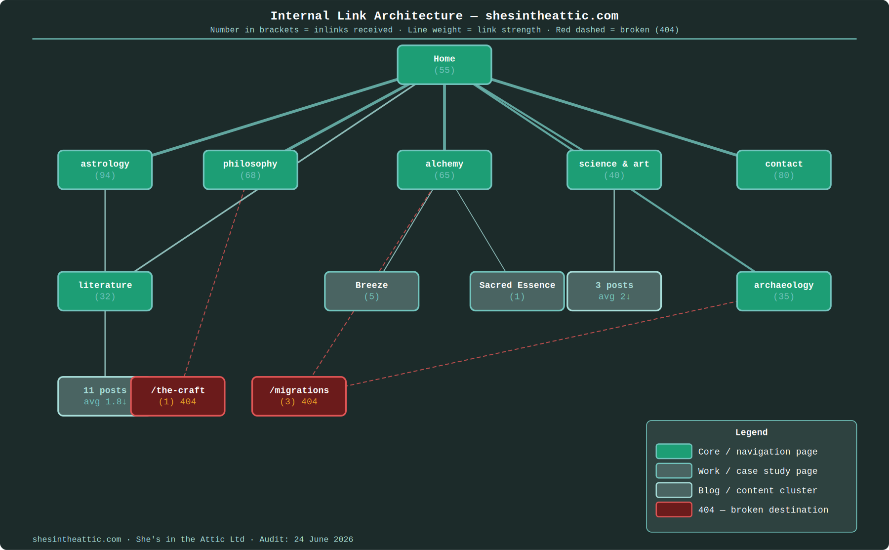
Internal link architecture — shesintheattic.com. 570 links. 24 June 2026. Numbers in brackets = inlinks received. Line weight = link strength. Red = broken link (404).

Full inlink data by page
Every page in the crawl, sorted by inlinks received. Pages with fewer than 3 inlinks are effectively invisible to internal link equity regardless of content quality.

Page | Inlinks | Indexable | Notes
astrology.html | 94 | Yes | Primary nav on every page — expected
contact.html | 80 | Yes | Contact button in header on every page
philosophy.html | 68 | Yes | Primary nav
alchemy.html | 65 | Yes | Primary nav
index.html / homepage | 55 | Yes | Homepage
science-and-art.html | 40 | Yes | Section index
archaeology.html | 35 | Yes | Section index
literature.html | 32 | Yes | Section index
privacy-policy.html | 29 | No | Footer link on every page
cookie-policy.html | 25 | No | Footer link on every page
work-pages/breeze-furnishings.html | 5 | Yes | Linked from alchemy.html only
astrology/001.html | 5 | Yes | Underlinked — only section index links here
astrology/011.html | 4 | Yes | Underlinked
migrations.html | 3 | No (404) | Broken. 3 pages pointing to nothing.
astrology/010.pdf | 3 | Error | Old PDF path. Still referenced by 3 pages.
astrology/009.html | 3 | Yes | Underlinked
science-and-art/the-basics-still-matter.html | 2 | Yes | Main content piece. Critically underlinked.
ga4-ai-traffic-tracking-guide.pdf | 2 | Error | PDF path returning error. Check file location.
science-and-art/001.html | 2 | Yes | Underlinked
science-and-art/002.html | 2 | Yes | Underlinked
astrology/003, 004, 005, 006, 007, 008, 008.1, 002 | 1 each | Yes | Single inlink each — no internal authority accumulation
the-craft.html | 1 | No (404) | Broken. Linked from philosophy.html.
work-pages/sacred-essence.html | 1 | Yes | Underlinked — linked from alchemy only

What this means
The blog posts are the commercial and editorial heart of the site. They demonstrate expertise, attract external links, and drive AI search citations. A post with a single inlink cannot accumulate internal authority regardless of content quality. The fix is deliberate: add contextual links from section index pages to individual posts, and cross-link between related posts. This is not a redesign — it is three or four thoughtfully placed links per page.

3. Entity Mapping — S.V.G.C.S
The Literature layer. Search engines and AI agents do not read individual words — they read relationships between concepts. The entity map shows what topics the site covers, how deeply, how those topics connect, and where the gaps are. A gap in the entity map is a gap in the site's ability to appear for related queries even if the content exists. This analysis uses the S.V.G.C.S methodology (Semantic Vector Generation and Compliance System).

⚠ S.V.G.C.S extraction pending. Full entity map will be built by running NLP extraction against crawled page content via Claude API, then comparing semantic coverage against competitor sites to identify gaps at topic and keyword level. This will be added to the next version of this document and will form the basis of the Part 3 LinkedIn content. Estimated: next session.

Initial coverage assessment — manual review

Entity / Topic | Coverage | Notes
Technical SEO | Strong | Multiple pages, case studies, six-layer methodology
AI Search Visibility | Strong | Blog posts, GA4 guide, Brave Search methodology
GA4 & Analytics | Strong | Dedicated guide, science-and-art section
Semantic Architecture | Partial | Referenced but not deeply covered yet
Structured Data / Schema | Gap — zero pages | No schema on any page. Machines cannot classify content.
Migrations | Gap — page missing | Referenced by 4 internal links. Page does not exist.
Conversion Tracking | Gap | Contact form / PDF download events unverified in GA4.

4. Accessibility Tree Audit
The Readability layer. An AI agent reads a webpage the same way a screen reader does — through the accessibility tree, not the visual layout. If a page has no semantic landmarks (<main>, <nav>, <header>), no labelled buttons, no structured headings, the agent cannot navigate it. This is not only a WCAG compliance issue. It is a machine readability issue. The same template fix that makes the site accessible to users with visual impairments makes it readable to Claude, Perplexity, and every AI assistant.

Template Type | Avg Score | Pages | Grade
Inner pages (astrology, work, science-and-art posts) | 99/100 | 16 | A
Homepage | 88/100 | 1 | B
Top-level pages (literature, archaeology, alchemy etc) | 85/100 | 10 | B
Contact page | 82/100 | 1 | B

Overall site score: 93/100 — Grade A

Issues identified
- 27× missing landmark — no <main>, <nav>, <header>. Template-level issue. One fix resolves all 27 across the site simultaneously.
- 12× unlabelled interactive elements — buttons and links without aria-label attributes.
- 2× unlabelled images — empty alt="". Confirm whether intentionally decorative.

Why the inner pages score 100
The astrology posts, work pages and science-and-art articles all score 100. Single-column content pages with clear heading hierarchy and no complex interactive elements. The template issues only affect top-level navigation pages. Fix the shared template first — it cascades across the whole site.

5. AI Readiness
Lighthouse signals and structured data. An llms.txt file tells AI agents what the site is about and how to use it — the equivalent of robots.txt for language models. Structured data tells search engines and AI systems what type of content each page contains. Without these signals a site is readable but unclassified. Lighthouse performance scores were not available this session due to a headless Chrome configuration issue on Mac — not a site problem. Scheduled for next session via PageSpeed Insights API.

Signal | Result | Status
llms.txt | Missing | FAIL
robots.txt AI bot rules | Not specified | WARN
Structured data / schema | 0 of 10 pages sampled | FAIL
Lighthouse performance scores | Pending — PageSpeed API quota reset | WARN
Lighthouse accessibility scores | Pending | WARN
Lighthouse SEO scores | Pending | WARN

Priority actions
- Create /llms.txt — follow spec at llmstxt.org. Highest single impact for AI discoverability.
- Add structured data — Article schema on all blog posts, Organization on homepage.
- Update robots.txt — add explicit rules for GPTBot, ClaudeBot, PerplexityBot, Google-Extended.
- Run PageSpeed Insights API — performance, accessibility and SEO scores across 4 key pages.

6. Brave Search Visibility
The Visibility layer, part one. Brave Search maintains its own independent index — not a reskin of Bing or Google. This matters because Brave powers the web results in Claude. Studies show 86.7% overlap between Claude's cited sources and Brave's top results. If a site does not appear in Brave it does not appear in Claude's answers. Visibility is tracked across 12 target queries in three groups: brand, services and content.

Query group | Queries | Found | Notes
Brand | 3 | 0 / 3 | Site not yet in Brave index
Services | 4 | 0 / 4 | Competitive terms, new site expected
Content | 5 | 0 / 5 | Blog post published days before crawl

Context
Zero visibility is the correct and expected baseline for a domain launched weeks ago. Brave crawls on its own schedule. The key opportunity is in proprietary terms — “svgcs seo” and “six layer seo audit” are used by no other site. When Brave indexes the domain these queries will return shesintheattic.com exclusively. Re-run in four to six weeks.

7. Google Search Console
The Visibility layer, part two. Google Search Console is the definitive record of how Google sees the site — which queries trigger impressions, which pages rank, average position, and click-through rate. For a new site this data accumulates over weeks and months. The GSC connection is live and authenticated via OAuth. The baseline is established and ready for the data to arrive.

Metric | Value | Status
Property verified | https://www.shesintheattic.com/ | OK
OAuth authentication | Live and working | OK
Total clicks (90 days) | 0 | WARN
Total impressions (90 days) | 0 | WARN
Average position | n/a — insufficient data | WARN

What to watch
- First impressions will appear once Google indexes the blog post. Expect within 2–4 weeks.
- First queries showing impressions will confirm which topics Google associates with the site.
- Position data on the-basics-still-matter.html and the GA4 guide will be the first meaningful signals.
- Re-run: node gsc/gsc-puller.js --site=shesintheattic --days=90

8. GA4 Traffic Analysis
The Science & Art layer — the commercial intelligence layer of the audit. GA4 tells us not just who is visiting but how they arrived, which pages they engage with, how long they stay, and whether they take any meaningful action. For a consultancy site the key metrics are engagement rate (are visitors reading or bouncing?), channel mix (how dependent on a single source?), and top pages (what are people actually interested in?). Data covers 90 days from property 532413038 (G-VFZHM6PX5Q).

Overview

Total Sessions | This Week | Prev Week | WoW Change
284 | 29 | 12 | +141.7%

Week-on-week increase of 141.7% is directly attributable to the Part 2 LinkedIn post published 24 June 2026.

Sessions by channel
Where visitors are coming from. For a new site with no paid activity, Direct and Organic Social dominating is expected and healthy. Organic Search will grow as indexing develops.

Channel | Sessions | % Total | What this means
Direct | 185 | 65% | LinkedIn audience going straight to the URL — brand awareness working
Organic Social | 60 | 21% | LinkedIn post clicks from the two carousels and blog link post
Referral | 29 | 10% | External sites linking in — worth investigating the specific sources
Organic Search | 5 | 2% | Expected for a new site. Will grow with indexing.
Unassigned | 5 | 2% | Sessions GA4 could not attribute — check tag fires on all pages

Top pages by sessions
Which pages visitors land on and engage with. The high session count on /astrology/004.html warrants investigation — it may have been shared externally.

Page | Sessions | Notes
/ (homepage) | 134 | Entry point for most Direct traffic
/astrology/004.html — Work Is A Four Letter Word | 54 | Investigate traffic source — possibly shared externally
/astrology.html | 47 | Section index — expected high traffic
/index.html | 45 | Appearing separately from / — investigate canonical
/philosophy.html | 40 | Credentials page — people checking who this is

Key metrics explained
For reference and for sharing with non-technical stakeholders.

Metric | What it means for this site
Sessions | A single continuous visit. One person can generate multiple sessions across different days.
Engaged sessions | Sessions where the visitor spent 10+ seconds, viewed 2+ pages, or triggered a key event. The most honest measure of genuine interest.
Engagement rate | Engaged sessions ÷ total sessions. A consultancy site should aim for 60%+. Not yet measurable at this traffic volume.
Direct traffic | Visitors who typed the URL, used a bookmark, or came from a link that did not pass referrer data (e.g. some apps, messaging).
Organic Social | Clicks from social platforms without paid promotion. LinkedIn in this case.
Unassigned | Sessions GA4 could not attribute to any channel. Usually a tag configuration or consent issue.
WoW (week on week) | This week vs the previous week. Used to track momentum rather than totals at early-stage sites.

9. Recommendations
Everything identified across all six layers, consolidated and prioritised. HIGH items directly affect search visibility, machine readability or have broken user journeys and should be addressed first. MEDIUM items affect performance and discoverability. LOW items are important but not time-critical. Work through in order. Re-crawl after completing HIGH items to confirm resolution.

HIGH priority

 | Issue | File(s) | Action
HIGH | 404 — /the-craft.html | philosophy.html | Change [ See the services ] link to /alchemy.html
HIGH | 404 — /migrations.html | archaeology.html, alchemy.html, astrology/002.html | Build migrations page or remove links
HIGH | PDF 404 — /astrology/010.pdf | Multiple pages | Update to /science-and-art/ga4-ai-traffic-tracking-guide.pdf
HIGH | llms.txt missing | Root domain | Create /llms.txt — follow spec at llmstxt.org
HIGH | Zero structured data | All pages | Add Article schema to posts, Organization to homepage
HIGH | Blog posts underlinked | science-and-art.html, astrology.html | Add contextual links from section pages to individual posts

MEDIUM priority

 | Issue | File(s) | Action
MED | Missing landmarks (27×) | Shared template | Add <main>, <nav>, <header> — resolves all 27 at once
MED | Unlabelled interactive (12×) | Shared template | Add aria-labels to buttons and links
MED | robots.txt AI bot rules | /robots.txt | Add GPTBot, ClaudeBot, PerplexityBot, Google-Extended
MED | Duplicate titles (4) | TBC — run query | Make unique per page
MED | Duplicate descriptions (4) | TBC — run query | Make unique per page
MED | Titles over 60 chars (9) | TBC — run query | Trim to under 60 characters
MED | Unassigned GA4 sessions | GA4 tag config | Verify tag fires on all pages
MED | /index.html vs / duplicate | Canonical config | Investigate and resolve — one canonical URL
MED | Image file sizes | All pages | Run PageSpeed Insights when API quota resets
MED | Logo white background | /assets/ | Replace via remove.bg with transparent PNG versions
MED | Cookie pop-up reappears | Consent plugin | Fix in Hostinger — reappears on every page visit

LOW priority

 | Issue | File(s) | Action
LOW | Migrations page | migrations.html | Write page — Visualsoft migration focus
LOW | Philosophy — On working together | philosophy.html | Add the "On working together" section
LOW | .co.uk redirect | Hostinger DNS | Confirm shesintheattic.co.uk redirects correctly
LOW | Astrology posts 001 & 002 | astrology/ | Write the acronym post and hiring checklist
LOW | S.V.G.C.S entity extraction | All pages | Run via Claude API — foundation for Part 3
LOW | Update Twine & Bark profiles | External platforms | Update copy to match current positioning

Re-crawl
Run after completing HIGH priority items to confirm resolution:
cd ~/Desktop/seo-mac && node crawler/crawler-v3.js --site=shesintheattic

She’s in the Attic Ltd · Company No. 16258691 · ICO No. CSN4052311 · shesintheattic.com
Prepared for internal use. Not for distribution.

